Test 1

Adjust the CSS in this document. Make all columns headers and their data centered unless their text content length (across all rows) is higher than 20.

**Initial Version of Screenshot:**

**Code update Output:**

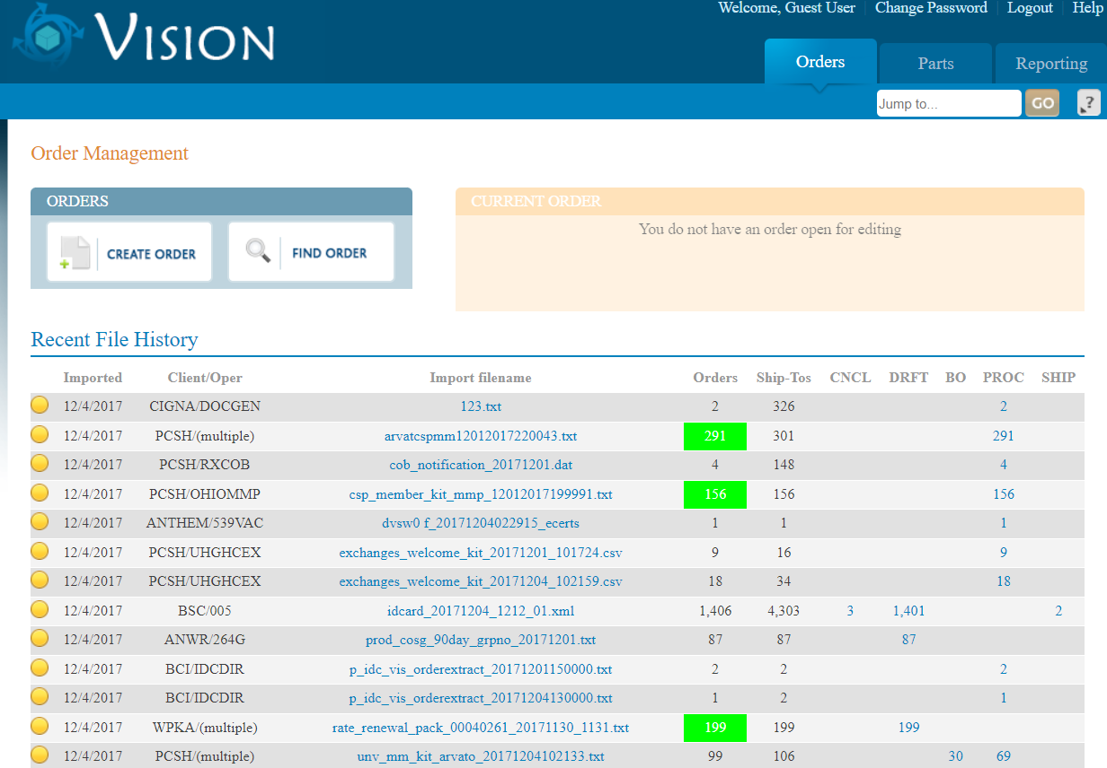

Test 2

Using jQuery and/or CSS to make all values in the “Orders” column of the Recent File History section higher than 100 have a background color of #00FF00 and the font color of #FFFFFF.

**Initial Version of Screenshot:**

**Code update Output:**



Test 3

Using jQuery and the button “jumpHelp” create a click event to create a dialog using div “dialog-jump” as its contents.

**Initial Version of Screenshot:**

**Code update Output:**



